Step1: sudo apt update: This command updates our all packages up to date. 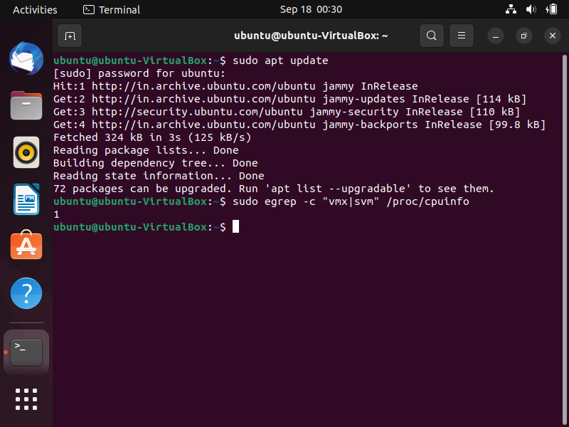

Step2: sudo egrep -c “vmx|svm” /proc/cpuinfo: this command tells whether virtualisation is working or not.

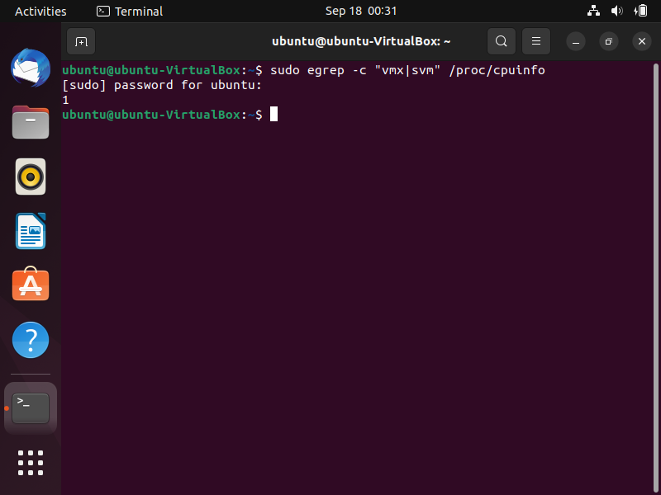

Step3: sudo apt install -y cpu-checker: this is used whether our hardware supports KVM.

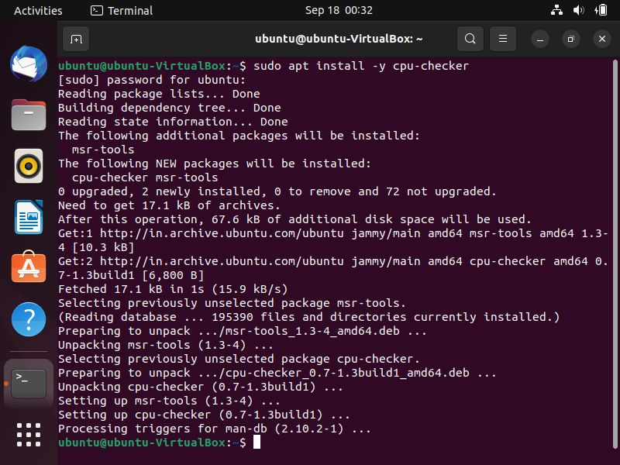

Step4: sudo apt update: This command updates our all packages up to date.

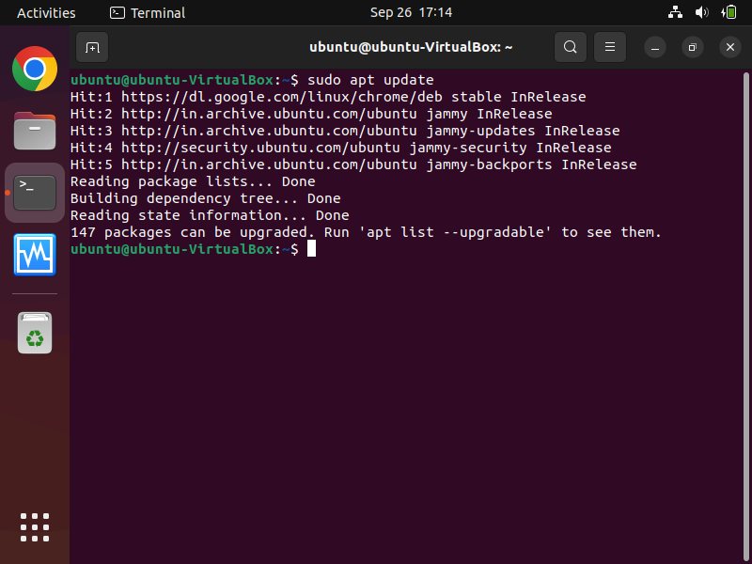

Step5: sudo kvm-ok: this command tell that we can use KVM.

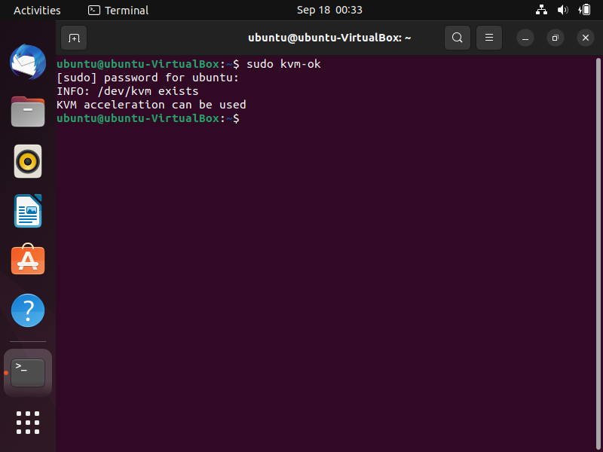

Step6: sudo apt install qemu: this command is used to install qemu.

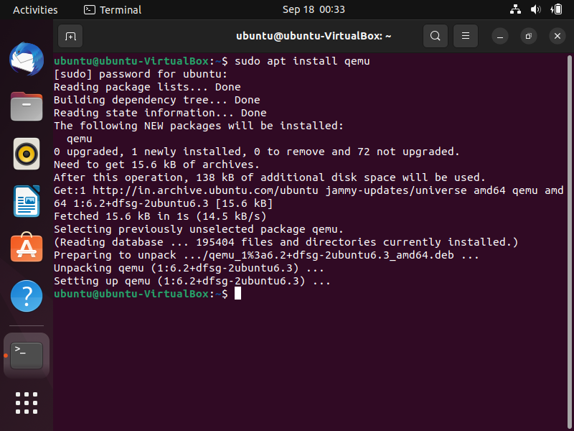

Step7: apt show qemu-system-x86: this command is used to check the version of qemu.

